**Application of Automata**

Here we will discuss five applications of Automata

1. DFA in compiler
2. Vending machine
3. Artificial Intelligence
4. Traffic Lights
5. Coin Operated Turnstile

**Name: Muhammad Arif Khan**

**Class: BSCS 2nd year Sec-B**

**DFA in compiler**

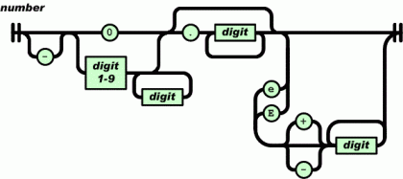In every programming language, the first step in the compiler or interpreter is the lexer(a program that breaks down the input source code into a sequence of lexemes). The lexer reads in a file of your favorite programming language and produces a sequence of tokens.

The lexer uses a DFA to go through the source file, one character at a time, and emit tokens. If you ever design your own programming language, this will be one of the first things you will write.

The picture given here is the automation to create numbers (integers, decimal, exponent form) in Computer

**Vending machine**

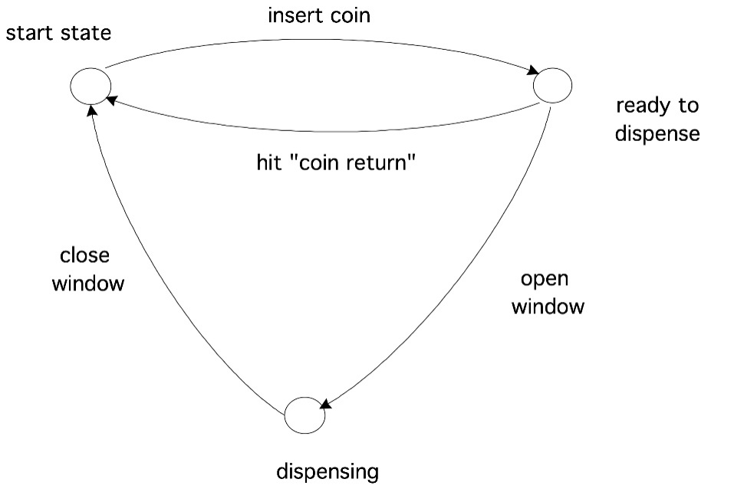A vending machine is an automated machine that dispenses numerous items such as cold drinks, snacks, beverages, alcohol etc. to sales automatically, after a buyer inserts currency or credit into the machine. Vending machine is works on finite state automate to control the functions process.

The automation given here is of a simple vending machine which holds only one type of item (e.g. Coca-Cola 500ml Bottle)

**Artificial Intelligence**

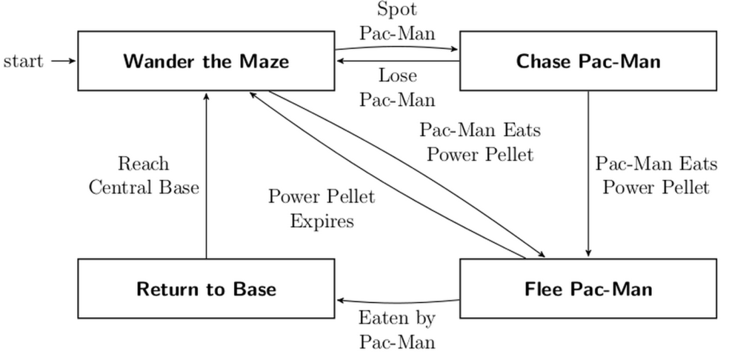Another application of finite automata is programming simple agents to respond to inputs and produce actions in some way. You can write a full program, but a DFA is often enough to do the job. DFAs are also easier to reason about and easier to implement.

Pac-Mania is an arcade video game in the Pac-Man series in which player have to eat all the dots and save himself/herself form enemy which chase the player when it is seen by the enemy.

The automation given here is the AI for Pac-Man which uses a four-state automaton:

**Traffic Lights**

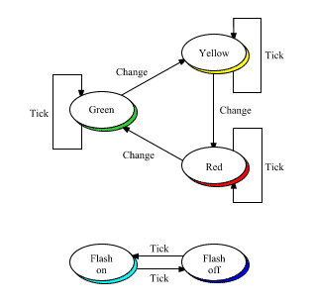The optimization of traffic light controllers in a city is a systematic representation of handling the instructions of traffic rules. Its process depends on a set of instruction works in a loop with switching among instruction to control traffic.

Here Automation can help in building a simple yet effective Traffic Light system.

Let say we are at state ‘Red’ and the string input is TickTickChangeTickTickTickTickChange

TickChange and further assume that one Tick equals one second then the machine will run and display ‘Red’ for two second ‘Green’ for four second and ‘Yellow’ for one second

**Coin Operated Turnstile**

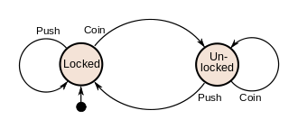A turnstile, used to control access to subways and amusement park rides, is a gate with three rotating arms at waist height, one across the entryway. Initially the arms are locked, blocking the entry, preventing patrons from passing through. Depositing a coin or [token](https://en.wikipedia.org/wiki/Token_coin) in a slot on the turnstile unlocks the arms, allowing a single customer to push through. After the customer passes through, the arms are locked again until another coin is inserted.

The turnstile has two possible states: ***Locked*** and ***Unlocked***.[[3]](https://en.wikipedia.org/wiki/Finite-state_machine#cite_note-Koshy-3) There are two possible inputs that affect its state: putting a coin in the slot (***coin***) and pushing the arm (***push***). In the locked state, pushing on the arm has no effect; no matter how many times the input ***push*** is given, it stays in the locked state. Putting a coin in – that is, giving the machine a ***coin*** input – shifts the state from ***Locked*** to ***Unlocked***. In the unlocked state, putting additional coins in has no effect; that is, giving additional ***coin*** inputs does not change the state. However, a customer pushing through the arms, giving a ***push*** input, shifts the state back to ***Locked***.